Task 6
- Create the admin users for the tomcat roles : manager-gui , admin-gui , manager-status
Follow the path
Step1: Add user and assign roles
/tomcat/tomcat2/apache-tomcat-9.0.98/conf and edit in vi tomcat-users.xml
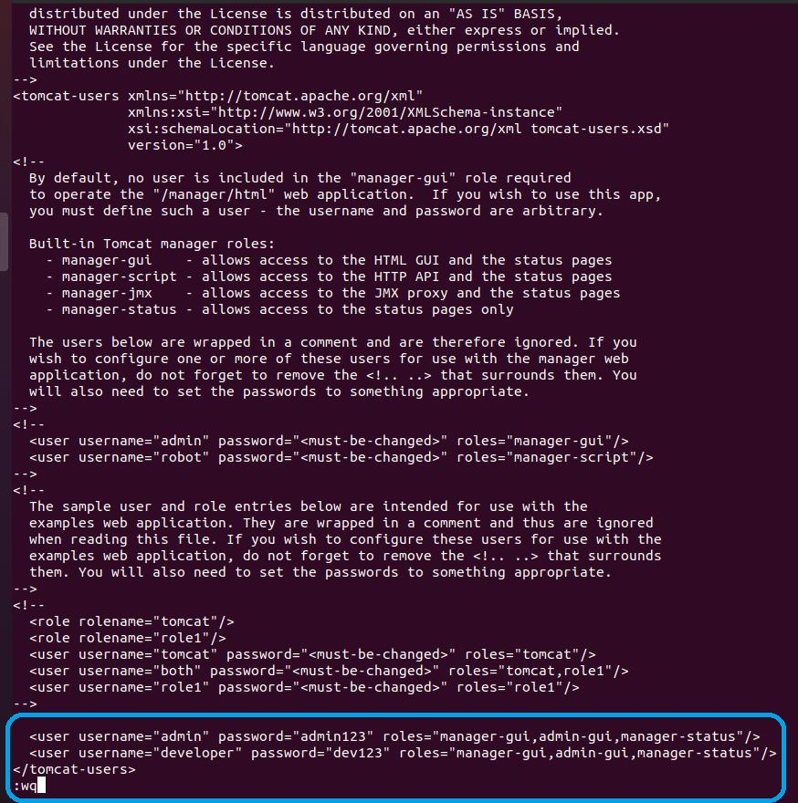

Step 2: Sign in
http://localhost:8081/manager/html
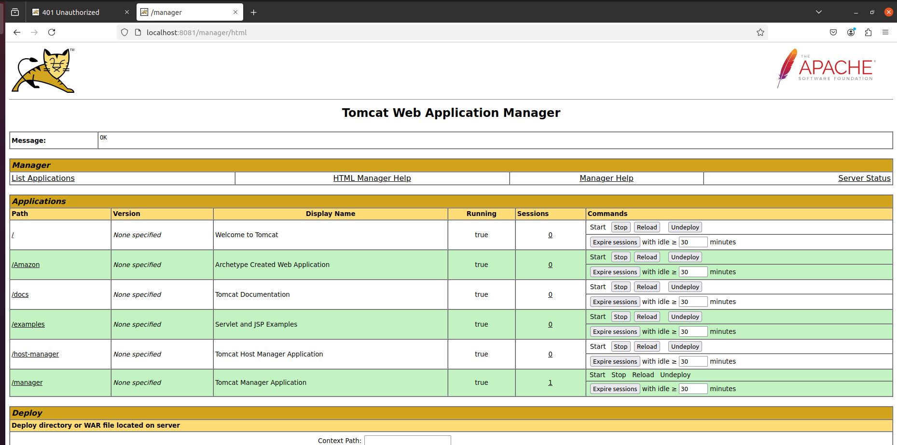
- Demonstrate the address bind excpetions
An Address Bind Exception occurs when a program (like Tomcat) tries to "claim" or "bind" a specific network port (such as port 8080), but the port is already being used by another program. Think of it like trying to park your car in a parking spot that is already taken by another car.

Simple Example:
- Problem: You have two programs trying to use the same parking spot (network port). Tomcat, for example, wants to use port 8080, but another program (maybe a web server or another Tomcat instance) is already using it.
- What happens? Tomcat tries to start up and use port 8080, but since the port is already taken, it can't start properly. Tomcat will throw an error called Address Bind Exception, saying that the port is already in use.
- Check if port 8080 is already in use: You can use the netstat or ss command to see which processes are using the ports.

.3. Run the 4 different tomcats in the same machines with different SP and CP

Follow the path to change the Shutdown port and Connector port
Step1:
/tomcat/tomcat3/apache-tomcat-9.0.98/conf and edit in vi server.xml
Shutdown port
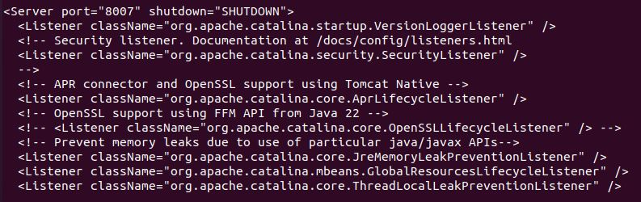
Connector Port
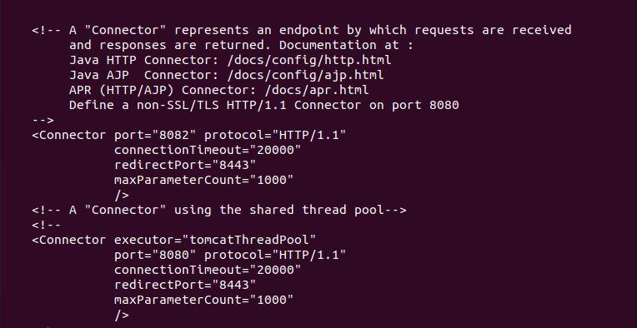

Step2:
And start tomcat in below mentioned path
/tomcat/tomcat3/apache-tomcat-9.0.98/bin and start the tomcat by using command sh startup.sh
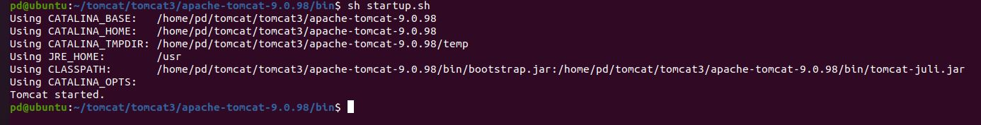
Note: sh startup.sh is for background start and sh catalina.sh run is for foreground start
Kind Attn: repeat the process step1 and step2 to change sp and cp to run tomcat simultaneously
Step3:
Check in Browser
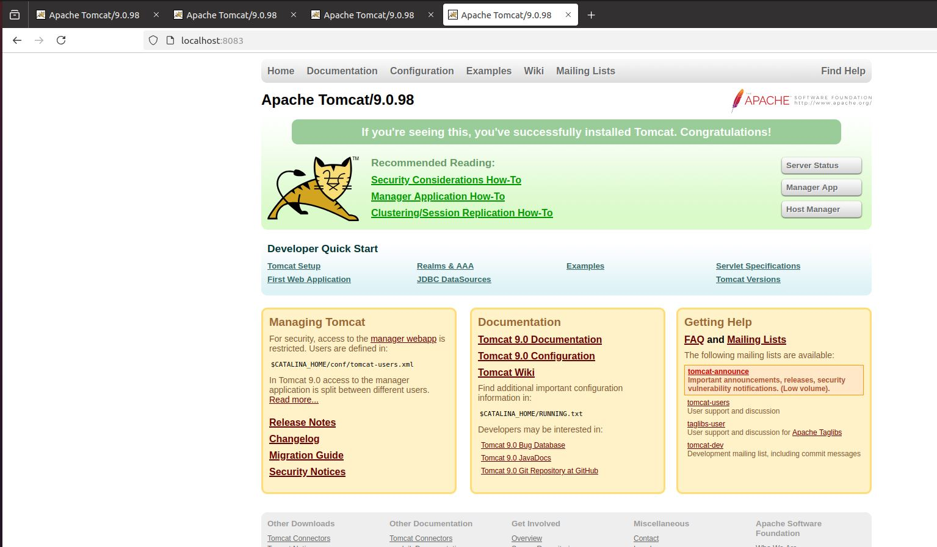

Note:
1. Default port of CP is 8080 and Tomcat listens on port 8080 for HTTP traffic
2. Default port of SP is 8085 and This is the port that Tomcat listens to for shutdown requests

